**Place matters for the poor: Digitisation and spatial inequality in Chile**

Pedro Fierro1, Ellen J. Helsper*2, Teresa Correa3, Matías Dodel4

1 Government School and Business School, Adolfo Ibanez University, Viña del Mar 2520001, Chile.

2 Department of Media and Communication, London School of Economics and Political Science, Houghton St, London WC2A 2AE, United Kingdom.

3 School of Communication, Universidad Diego Portales, Vergara 240, Santiago 8370067,

Chile.

4 Social Sciences Department, Universidad Católica del Uruguay, Av. 8 de Octubre 2738, Montevideo 11600, Uruguay.

* Corresponding Author: Ellen J. Helsper, Department of Media and Communication, London School of Economics and Political Science, Houghton St, London WC2A 2AE, United Kingdom. Mail: e.j.helsper@lse.ac.uk

**Declaration of competing interests**

We have nothing to declare.

**Acknowledgements**

This work was supported by FONDECYT project # 1231927, ANID-Millennium Science Initiative Program # NCS2022_046, and the ANID-Millennium Science Initiative Program # NCS 2024_007.

**CRediT authorship contribution statement**

**Pedro Fierro:** Methodology, Writing – review & editing, Formal analysis, Writing – original draft, Conceptualization. **Ellen J. Helsper:** Methodology, Writing – review & editing, Formal analysis, Writing – original draft, Conceptualization. **Teresa Correa:** Methodology, Writing – review & editing, Formal analysis, Writing – original draft, Conceptualization. **Matías Dodel:** Methodology, Writing – review & editing, Formal analysis, Writing – original draft, Conceptualization.

**Place matters for the poor: Digitisation and spatial inequality in Chile**

## ****Abstract****

This paper examines the extent to which digitisation can foster political inclusion in the context of a centralised political system with spatial inequalities. Digital technologies could offer new opportunities for political inclusion—particularly in territorially marginalised areas in administratively centralised contexts—but the realisation of these benefits faces structural challenges. Using Chile as a case study, the analysis is twofold. First, we investigate the factors associated with the digitisation of 343 municipal governments. Second, we explore how both territorial and individual-level characteristics relate to digital engagement—attitudinal (online political efficacy) and behavioural (use of municipal websites)—using data from 9,924 face-to-face surveys in the Chilean region of Valparaíso. At the municipal level, the results show that territorial inequalities continue to determine access to digital services since larger and wealthier localities tend to provide more digital services (although these patterns vary across regions). At the individual level, living in a digitised municipality is positively associated with the likelihood of using digital services. Additionally, socioeconomic status operates differently depending on the context. Wealthier individuals are more likely to engage online, but on average digital engagement is greater in poorer areas—suggesting that digital tools may be particularly valued where other forms of participation are limited. When individual and spatial dimensions of wealth are considered jointly, the results suggest that place makes a difference particularly for the engagement of disadvantaged individuals. Wealthy individuals engage no matter where they live. These findings highlight the potential of digitisation to promote spatial political inclusion.

**Keywords:** local governments; digital inequalities; digitization; civic engagement; online participation

## INTRODUCTION

The inclusion of digital technologies in local administrations, also referred to as electronic, digital, or smart government, is argued to have the potential to streamline and simplify governmental processes and thus improve efficiency (Gerpott & Ahmadi, 2016). Additionally, by enhancing transparency in governance, facilitating service delivery through new platforms, and enabling more inclusive participation, digital transformation could foster higher levels of citizen and social engagement for certain populations (Gasco Hernandez, 2024). Nonetheless, diverse factors hinder the potential of government services’ digitisation, research shows that adoption of digitised services is stratified similar to other socio-digital inequalities with socioeconomic and age disparities, as well as urban-rural gaps (Dodel, 2024; Robles et al., 2022).

In this context, this study seeks to examine the extent to which digitisation can foster political inclusion in a centralised and spatially unequal setting, where residents of certain areas have historically been marginalised from political discourse. To this end, the paper pursues two specific objectives. First, it seeks to identify the factors that may influence the digitisation of local governments at the municipal level. Second, it examines the relationships between these processes of local governments and the digital political engagement of citizens at the individual level, focusing on both attitudes (i.e. online political efficacy) and behaviours (i.e. effective use of municipal websites). To address the first aim, we use official data from the Chilean government and the Digital Municipal Index, recently developed by the Millennium Nucleus of Inequalities and Digital Opportunities (NUDOS). For the second aim, we incorporate survey data from 9,924 face-to-face surveys conducted by IPSOS and Datavoz-Statcom in the Chilean region of Valparaíso.

First, at the municipal level, the results suggest that municipal income of local governments seems to explain their level of digitisation, although these relationships vary by region. And second, at the individual level, the findings show that living in a more digitised municipality increases the likelihood of using digital services. However, residents of wealthier municipalities are less likely to use these services and to view the digital tools as politically empowering—regardless of their level of digitisation. Conversely, individuals with higher socioeconomic status are more likely to engage digitally and perceive greater political efficacy online. When spatial and individual wealth are considered in interaction, the results suggest that place of residence matters most for those who are individually disadvantaged. In other words, affluent individuals are likely to engage digitally regardless of where they live. By contrast, deprived individuals show significantly higher levels of engagement when they reside in marginalised areas. This pattern highlights that digital engagement tools may be perceived as particularly valuable by low-income individuals in disadvantaged contexts, where other channels for participation are more limited.

This study contributes by identifying spatial patterns in the broader debate on governmental digitisation, spatial and digital inequalities. The findings also raise questions about the digitisation of local governments in Chile—a process that appears closely tied to pre-existing territorial inequalities—as no clear evidence was found that higher levels of digitisation consistently lead to greater local engagement.

## THEORETICAL BACKGROUND

### Digital technologies in local governments

As digital technologies have been integrated into the operations of the public sector, digital government or e-government has become a phenomenon that has led to emerging forms of leadership, new decision-making processes and ways of organising and delivering services as well as new notions of citizenship (Gil-Garcia et al., 2018). Early research identified a range of benefits associated with e-government initiatives, including enhanced accessibility for citizens, greater operational efficiency, and increased transparency in public service delivery (e.g. Beynon-Davies, 2005; Saha, 2009). Besides promoting more agile and responsive governance, the use of digital technologies has also been credited with shifting towards a more citizen-centred approach. By facilitating direct interactions between governments and citizens, digital technologies can potentially reduce the need for intermediaries, streamline procedures, and make public institutions more accessible and accountable (Janssen & van der Voort, 2016).

In recent years, researchers have refined definitions of these phenomena, with particular emphasis on "digital transformation" and how this process intersects with institutional capacity, governance culture, and public trust (Gil-Garcia et al., 2018; Janssen & van der Voort, 2016). As such, the study of government and digital technologies has evolved from a focus on efficiency gains to include more nuanced considerations of organisational change, democratic engagement, and equity in access. According to Gasco Hernandez (2024), government digital transformation is a broader concept that includes cultural, organisational, and relational changes aimed at achieving the objectives and goals of reforms. Understanding that digitalisation encompasses various aspects and dimensions, this study focuses on a particular part of the process: digitisation as the adoption of new delivery channels, i.e., online platforms (Mergel et al., 2019).

Research has paid attention to the role of digitisation in the internal operations of governments, such as optimising bureaucratic workflows, reducing processing times, and enhancing coordination across different units (e.g. Cordelia, 2007). Additionally, as process simplification is combined with the ubiquity and 24-7 availability of services enabled by digital technologies, digitisation also makes government services more accessible to individuals (Botrić & and Božić, 2021; Dodel, 2024). Digitisation thus reduces—at least partially—the administrative burdens for individuals: the non-monetary costs placed on them when they use government services (Larsson, 2021; Madsen et al., 2022).

In these terms, digitisation in local governments holds significant potential to mitigate not just interpersonal inequalities, but also spatial ones by creating novel forms of participation and engagement that are not bound by geographic constraints. Through digital platforms, residents in remote or underserved communities can potentially access public services, contribute to local decision-making processes, and engage in civic life in ways that were previously limited by physical distance or infrastructural deficits (Toro-Maureira et al., 2025; van Dijk, 2020). However, realising the potential of digitisation and digital transformation requires careful attention to existing gaps. While digital technologies can transcend physical space, their opportunities depend on adequate infrastructure, digital literacy, and institutional capacity (Helsper, 2021; Pavez et al., 2025).

### Digital and spatial inequalities at the local level

Digital inequality theories commonly conceptualise digital inequalities along three levels. The first-level refers to disparities in access to digital technologies, including infrastructure, devices, and internet connectivity. The second-levelfocuses on differences in digital skills and how people use technologies, highlighting that not all users are equally equipped to navigate or benefit from digital tools (Di Maggio et al., 2004). Finally, the third-level digital addresses the outcomes of digital engagement, emphasising that even when people have access and skills, the benefits they obtain—such as educational, economic, or civic engagement—can vary significantly depending on social and structural factors (van Deursen & Helsper, 2015; van Dijk, 2020). These three levels show that digital inequality is not only about access but also about effective use and its implications. Thus, research has consistently shown that historically marginalised groups—such as rural, lower-income, less-educated, and older populations—tend to be disadvantaged in the digital realm not only because there are disparities in access and skills, but also in how they benefit from digital technologies, thus amplifying broader societal inequalities (Helsper, 2021; Ragnedda & Ruiu, 2019; Robinson et al., 2015). Most of the literature on digital inequalities has focused on systematic inequalities between socio-economic (e.g. income, education, class) and socio-cultural (e.g. gender, age, ethnicity) groups in their access to infrastructure, devices and connectivity (e.g. Correa et al., 2021; van Dijk, 2020). These inequalities also extend to differences in digital skills and engagement, reinforcing pre-existing patterns of social exclusion (Hargittai, 2010; van Deursen & van Dijk, 2014).

While much of the literature on digital inequalities has focused on disparities between social groups, less attention has been devoted to spatial gaps. Early narratives of the digital revolution suggested that the Internet would render physical location increasingly irrelevant (Cairncross, 1997), paving the way for a deterritorialised public sphere and a redistribution of power (Kneuer & Datts, 2020). However, scholars have shown that access to information and digital participation remain spatially constrained, with certain citizens—and the places they inhabit—exerting influence and control over others in the digital sphere (Graham et al., 2018; Toro-Maureira et al., 2025). In this way, the online environment often mirrors existing territorial power structures, reproducing the hierarchies and inequalities present in physical space (Stephens & Poorthuis, 2015; Takhteyev et al., 2012). This dynamic reinforces earlier critiques suggesting that digital technologies may not simply erase distances, but instead generate new forms—or deepen existing forms—of territorial inequality and uneven development (Gillespie & Robins, 1989).

Previous research suggests that spatial location—whether urban or rural, central or peripheral—plays a fundamental role in the study of digital divide (Correa et al., 2017; Graham et al., 2012, 2018; Mossberger et al., 2021). Much of this literature focuses on the first-level, emphasising disparities in infrastructure, connectivity, and access. In turn, explanations for these inequalities often highlight the role of regional economic resources: wealthier areas tend to benefit from stronger broadband infrastructure, while poorer and rural regions must rely on public investment or subsidies to ensure even basic connectivity (Mossberger et al., 2012; Pavez et al., 2025; Whitacre et al., 2015).

Building on this framework, this paper tests the following hypotheses with Chile as a case study:

**H1:** Municipalities with higher permanent incomes are likely to exhibit higher levels of digitisation.

**H2:** Municipalities with a larger rural population share are likely to exhibit lower levels of digitisation.

**H3:** Municipalities with a larger professional workforce are likely to exhibit higher levels of digitisation.

At the same time, given Chile’s pronounced centralisation and territorial inequalities (OECD, 2017), it is important to note that these relationships may not be consistent across the entire country. Therefore, accounting for contextual and regional variation is essential in further analyses.

### Local governments, spatial inequality and citizen digital engagement

Over the last decade, inequality scholars and social geographers have shown that in areas that have been left behind, inhabitants experience feelings of anger, frustration, or abandonment due to economic decline (Dijkstra et al., 2020; Rodríguez-Pose, 2018; Rodríguez-Pose et al., 2024), deindustrialisation (McCann, 2020; Rodríguez-Pose et al., 2023), and political or historical marginalisation (Cramer, 2012; Pavez et al., 2023; Ziblatt et al., 2023). This phenomenon extends beyond individual experiences to include contextual factors that may also explain the rise of populism, anti-elitism, and nationalism in both consolidated and emerging democracies (e.g. Essletzbichler & Forcher, 2022; Faggian et al., 2021; Ziblatt et al., 2023). In this context, a critical question arises: how can segregated territories—and their inhabitants—be effectively included in political processes?

As scholars have noted, current analyses of governments and local administrations today cannot be separated from their digital dimensions (Gasco Hernandez, 2024). Examining digital inequalities at the subnational level reveals even greater complexity due to spatial disparities. One possibility is that in centralised and spatially concentrated contexts, digital platforms can create new opportunities for residents of marginalised territories—opportunities that may extend to political attitudes and perceptions. A useful lens for analysing how digital platforms can foster political inclusion at the attitudinal level is the concept of political efficacy. Originally developed by Campbell et al. (1954), political efficacy refers to the belief that political action can lead to change, and it has been widely used to study political attitudes and inclusion in Latin America (e.g. Torcal & Montero, 2006). More recently, scholars have introduced a distinct dimension tailored to the digital sphere—Online Political Efficacy (OPE)—which captures the individuals' beliefs that the internet empowers citizens politically (Sasaki, 2016, 2017). Thus, it is worth exploring the extent to which local governments’ digital efforts are associated with a greater sense of political efficacy, particularly in the online sphere. To examine this at the individual level, the following hypothesis will be tested:

**H4a:** Individuals living in municipalities with higher levels of digitisation are likely to report greater OPE—that is, the belief that, thanks to the Internet, they have more political power and influence.

Additionally, for the specific case of Chile, it has been shown that residents of politically and culturally marginalised areas are more likely to view digital platforms as mechanisms for having their voices heard, particularly given that these groups often have fewer resources for political engagement through traditional means (Fierro et al., 2023; Pavez et al., 2023). A similar dynamic may also apply in contexts of territorial socioeconomic inequality. Accordingly, the following hypothesis will be tested:

**H4b:** Individuals living in less wealthy municipalities are likely to report greater OPE—that is, the belief that, thanks to the Internet, they have more political power and influence.

In terms of behavioural engagement, debates on the relationship between the Internet and local participation have extended into the realm of public administration, particularly regarding the activities of local governments. With the increasing necessity—or inevitability—of digitalising local governments, scholars have explored how the Internet shapes the civic development of local communities. For example, Haro-de-Rosario et al. (2016) found that in Spain, online transparency, interactivity, and local governments' activity on social media are key drivers of involvement, i.e., engagement in political and social affairs of the local government. Similarly, Lappas et al. (2022) highlighted the significance of dialogic approaches and the promotion of offline activities through social media platforms in fostering online engagement in Greece. Thus, extending these previous findings, this study aims to test the following hypothesis:

**H5a:** Individuals living in municipalities with higher levels of digitisation are more likely to engage digitally with local government—such as administrative issues, transparency, and accountability.

Additionally, in line with the reasoning applied to Online Political Efficacy—i.e. that digital platforms are particularly relevant for inhabitants of marginalised places—, the following hypothesis will be tested:

**H5b:** Individuals living in less wealthy municipalities are more likely to engage digitally with local government —such as administrative issues, transparency, and accountability.

One question that remains unexplored in the literature is how individual and spatial wealth interact in shaping engagement with local government through digital platforms. Since this specific intersection has not received attention and is undertheorized, it is difficult to formulate hypotheses in this area. On one hand, it could be argued that wealthier individuals living in marginalised areas are best positioned to take advantage of digital services, given their individual resources might support better quality access and skills and because they tend to be more motivated to engage politically. On the other hand, it is also plausible that disadvantaged individuals in marginalised areas are the ones who find digital platforms particularly useful, precisely because they lack access to other forms of formal engagement. In this sense, digital services may serve as a compensatory mechanism, helping those with fewer resources engage politically despite structural barriers.

Therefore, the paper makes an original contribution by trying to answer the following exploratory question (**RQ1**): Do the economic resources of the area in which people live influence how individuals’ socio-economic status impacts their digital engagement with local government?

## METHODOLOGY

To test the hypotheses and address the research question, this study employs a sequential design, incorporating two phases of data collection. First, to analyse the contextual factors influencing digital performance across municipalities, we used municipal-level data. Analyses were conducted using data from the Digital Municipality Index, developed by the Millennium Nucleus of Inequalities and Digital Opportunities (NUDOS), which assesses the availability of online information and services provided by municipalities through their official websites. Additionally, official data from the National System of Municipal Information (SINIM), provided by the Chilean Government, was used. Second, to explore the relationship between local government digital performance and citizen engagement, we used individual-level data from an annual survey conducted in the Chilean region of Valparaíso between 2018 and 2023 (n = 9,924).

### Case Study justification: Chile and Valparaiso

The first part of this study—which seeks to explain the degree of municipal digitisation in each area by considering various sociodemographic characteristics—focuses on the 343 continental municipalities of Chile (excluding Easter Island and the Juan Fernández Archipelago). In recent decades, Chile has been recognised for its political and institutional stability, its robust party system, and its strong rule of law (Mainwaring & Scully, 2008; Roberts, 2015). However, the country has also experienced one of the most profound political and social crises in its recent history, culminating in a mass social uprising in October 2019, when more than two million people took to the streets (Navarrete & Tricot, 2021; Somma et al., 2021), followed by two failed constitutional processes (Paredes et al., 2025).

Several explanations have been proposed to account for these events, many of which relate to longstanding issues of political representation (Bargsted & Somma, 2013; Luna, 2016) and deep-rooted social inequality (Hechler et al., 2024), both interpersonal and spatial. Chile has long been characterised by extreme centralisation (OECD, 2009, 2017) and spatial concentration (Fierro, Aroca, et al., 2025). As a result, substantial differences now exist between municipalities. For example, according to official data reported by local governments, the autonomously generated recurring revenue[1] of the Municipality of Las Condes (an affluent area in the capital region) amounted to approximately USD 215 million in 2023, whereas in Tortel (a small municipality in southern Chile), it totalled only about USD 70,000.

Chile with its 19-million inhabitants offers a compelling case for analysing the interplay between digital government and inequality due to its high levels of internet penetration and advanced e-government infrastructure, alongside persistent socioeconomic and digital disparities. Household internet access rose sharply from 70 % in 2015 to 94% in 2023 (Subtel, 2023), a trend largely driven by public initiatives aimed at expanding coverage and promoting mobile connectivity. For instance, the Telecommunications Development Fund has subsidised mobile access in low-income and geographically remote areas (Pavez et al., 2025). Chile’s digital advancement is also evident in its e-government agenda. As of 2023, 89% of administrative procedures could be completed online (Datta, 2023). The country reached a turning point during the COVID-19 pandemic, when the Digital Government Unit scaled up the use of *ClaveÚnica* (UniqueKey), a secure, personal digital identity system that links individuals’ national ID numbers to a digital key for accessing public services. This innovation triggered a widespread shift from in-person to digital interactions with the state. Thus, individuals can apply remotely for benefits and subsidies, obtain official documents, and file complaints, streamlining interactions with the state (Toro-Maureira et al., 2025).

To examine how digitisation and wealth relate to individuals’ digital local engagement, we specifically focused on the region of Valparaíso, the second most populous region in Chile, home to 10.3% of the country’s population. Over the past decades, it has played a significant role in the national political landscape: it hosts the National Congress and was one of the main centres of protest during the 2019 social uprising (INDH, 2019). Its distinctiveness and political relevance make Valparaíso an interesting case study. At the same time, as Table 1 shows, Valparaíso shares similar characteristics with the national average in terms of sociodemographic, digital connectivity, and political indicators. While the results cannot be directly generalised to the entire country, they offer a reasonable basis for testing our hypotheses and answering our research question about broader patterns.

**Table 1.** Comparison of Sociodemographic, Digital, and Political Indicators for Chile and the region of Valparaíso

|  |  |  |  |
| --- | --- | --- | --- |
|  |  | Chile | Region of Valparaíso |
| Sociodemographic | Age (mean) | 38.1 | 39.5 |
| Gender (% of female) | 51.5 | 51.8 |
| Households with kids | 33.2 | 30.9 |
| Immigrant population (%) | 8.8 | 5.3 |
| Digital | Fixed line connectivity | 71.3 | 74.4 |
| Mobile connection | 76.1 | 87.6 |
| Political | Turnout last presidential elections* | 55.68 | 57.62 |
| Turnout last local elections | 84.9 | 84.9 |

*Source: Own elaboration using official data of the Chilean Census 2024, Subtel (2023) and Servel (National Electoral Service).*

*\* These elections were conducted with a voluntary voting system.*

### Municipal-Level Data

First, municipal-level data was considered, covering the 343 mainland municipalities of Chile (excluding Juan Fernández and Easter Island).

***Digital Municipality Index (DMI).*** The level of digitisation was measured using the Digital Municipality Index, which is one dimension of a Communal Digitalisation Index. The DMI evaluates the development of digital services in local governments by assessing the availability of online payment services, support for administrative procedures, and access to information and transparency through municipal websites. Specifically, it captures which of 34 online services each municipality offers. These services are grouped into two categories: “Payments, procedures, and online services,” which includes 13 activities, and “Information and transparency,” which includes 21 activities. Figure 1 shows the spatial distribution of the DMI across the 343 municipalities included in the study, highlighting variation in levels of digitisation across territories.

**Figure 1.** Spatial distribution of DMI at the municipal level in Chile

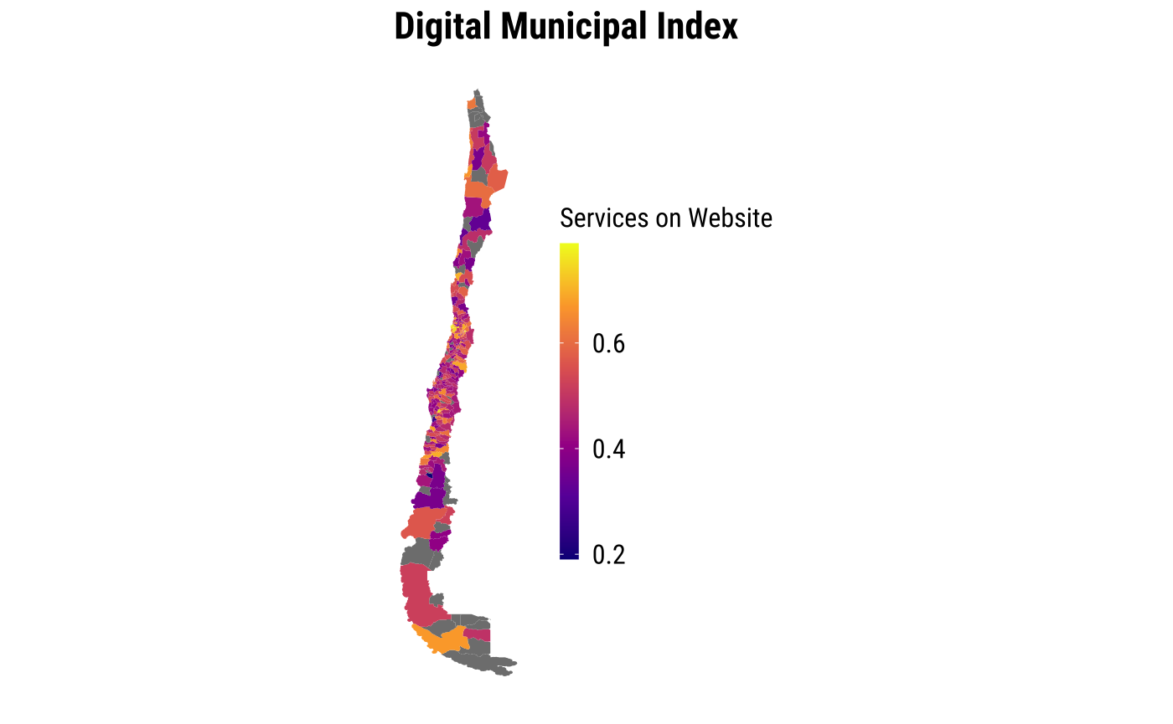

*Source: Own elaboration with data publicly available at* [*https://indice.nudos.cl/*](https://indice.nudos.cl/)*.*

***Municipal Income.*** To capture the economic wealth of each municipality, we included a measure based on autonomously generated recurring revenues for 2023, expressed in log terms (see Figure 2). This data was also obtained from the National Municipal Information System (SINIM).

***Share of Rural Population.*** Rurality was captured by the percentage of the population living in rural areas within each municipality in 2023 (see Figure 2). This data was also obtained from the National Municipal Information System (SINIM).

***Qualified Municipal Workforce.*** To capture the professional human resources of each municipality, the percentage of employees with a professional degree in 2023 was considered (see Figure 2). The data comes from the National Municipal Information System (SINIM).

***Control Variable***. Municipality’s population was included, measured as the projected number of people living in each municipality in 2023, expressed in log terms. The data comes from the National Municipal Information System (SINIM). Additionally, territorial fixed effects were included at the regional level, corresponding to Chile’s 16 first-level administrative divisions.

**Figure 2.** Spatial distribution of socioeconomic indicators at the municipal level

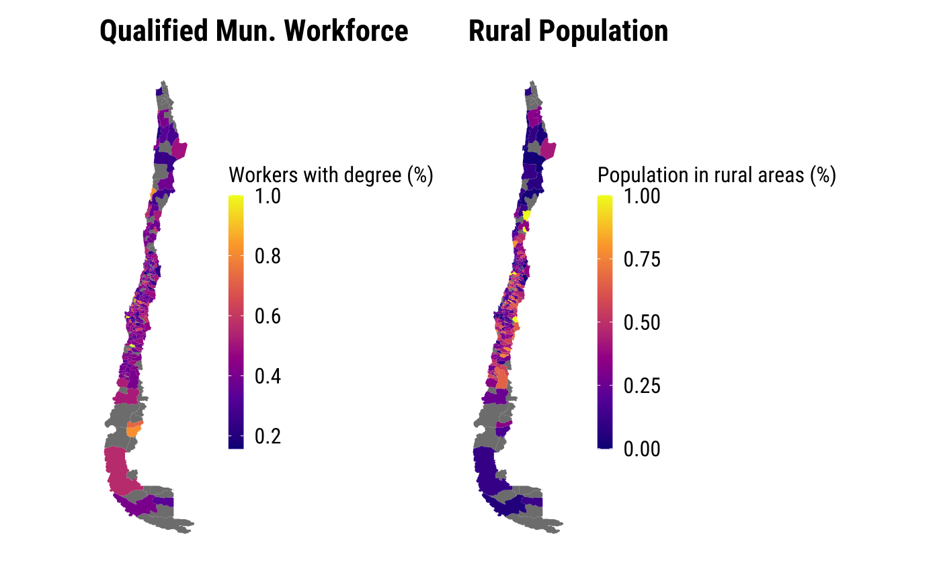

*Source: Own elaboration with data publicly available at SINIM. https://www.sinim.gov.cl/*

### Individual-Level Data

Secondly, we use data from the Political Opinion Survey (EOP), developed by Fundación P!ensa and conducted with IPSOS and Datavoz-STATCOM. The survey employs a probabilistic, non-proportional design with a three-stage random sampling method (by block, household, and individual), targeting men and women aged 18 and older. This paper considers six versions of the survey from 2018 to 2023, encompassing 9,924 face-to-face interviews conducted in the ten largest cities in the Valparaíso region of Chile. According to the 2024 census, 71% of the regional population resides in these cities.

***Living in a Digitised Municipality.*** To examine contextual factors that may influence our variables of interest at the individual level, we included a variable to determine whether respondents live in a highly or minimally digitised municipality. Specifically, the value of the DMI (measured at the municipal level) was assigned to individuals based on their place of residence. To prevent misinterpretations and ecological fallacies, it is essential to clarify that this variable does not represent individual use of services but indicates that an individual lives in a municipality with diverse levels of digital services offering.

***Living in a Wealthy Municipality.*** Additionally, we considered the impact of residing in a wealthy municipality. This was measured by assigning the Municipal Income level to individuals based on their municipality of residence and the year of version of the survey. This measure does not reflect individual income; it captures the effect of living in a municipality with a certain level of economic resources.

***Socioeconomic Status:*** Individual socioeconomic status was measured using the standard 5-point scale commonly applied in Chile (ABC1 = 1, C2 = 2, C3 = 3, D = 4, E = 5). For interpretative consistency, the scale was inverted so that higher values indicate higher socioeconomic status (i.e., 1 = lowest, 5 = highest). The variable ranges from 1 to 5, with a mean of 2.93 and a standard deviation of 1.07.

#### Political Attitudinal Engagement.

***Online Political Efficacy.*** To measure online political efficacy, we follow the approach proposed by the World Internet Project (Sasaki, 2016, 2017), asking respondents to indicate their agreement with the following statements:

1. Using the internet, people like me have more political power (power).

2. Using the internet, I can have a greater voice regarding what the government does (voice).

3. Using the internet, it is easier for me to understand politics (understanding).

4. Using the internet, public officials are more concerned about what I think (concern).

Each of these questions was measured on a 5-point Likert scale, where 1 indicates strong disagreement and 5 indicates strong agreement. These variables were included as discrete measures addressing different aspects of Online Political Efficacy, alongside a factor representing a general measure of OPE using Confirmatory Factor Analysis (CFA). The resulting factor demonstrated good internal consistency, with a Cronbach’s alpha of 0.83.

#### Political Behavioural Engagement.

***Awareness and Use of Municipal Website.*** To measure specific uses of the official local government website, respondents were asked to indicate their agreement with the following statements:

1. I am aware of the existence of the municipal website (know_web).

2. I have used the municipal website to complete administrative procedures and/or make service payments (use_adm).

3. I have used the municipal website to seek information from the municipality (use_info).

4. I have used the municipal website to request transparency information (use_transp).

5. I have used the municipal website for other purposes (use_other).

Each of these questions was measured as a binary variable, coded as 1 for “yes” and 0 otherwise. These variables were included as discrete measures that capture different aspects of awareness and use, alongside a general factor of use created using Confirmatory Factor Analysis (CFA), incorporating the variables “use_adm”, “use_info”, “use_transp”, and “use_other”. Given the binary nature of these variables, a Weighted Least Squares Mean and Variance adjusted (WLSMV) estimator suited for categorical indicators was employed. The resulting factor demonstrated good internal consistency, with a Cronbach’s alpha of 0.75.

***Control Variables***. Various sociodemographic variables were included as control variables, such as age (mean=47.45 ; std. dev.=17.78 ; min=18; max=95 ) and gender (“1” if women and “0” otherwise; mean=0.6 ). Additionally, we included political interest, measured using a self-reported approach. Specifically, all respondents were asked how interested they were in the following areas:

1. Politics

2. Issues happening in the world

3. Issues happening in the country

4. Issues happening in their region

5. Issues happening in their neighbourhood

Each question was measured on a 4-point Likert scale, where 1 indicated 'no interest' and 4 indicated 'strong interest.' Using confirmatory factor analysis (CFA), a factor for political interest was constructed from these responses. The resulting factor demonstrated good internal consistency, with a Cronbach's alpha of 0.86.

## RESULTS

### National Analysis at the Municipal Level

First, the analyses focused on the national context, using aggregated data at the municipal level. Descriptive analyses show that the Digital Municipal Index (DMI) score is higher in more urban, wealthier municipalities with a lower qualified workforce (see Figure 3).

**Figure 3.** Dispersion diagram of the DMI, considering rural population, municipal income and qualified municipal workforce.

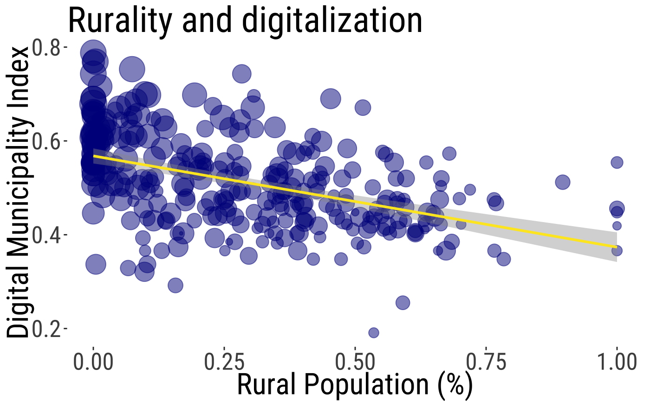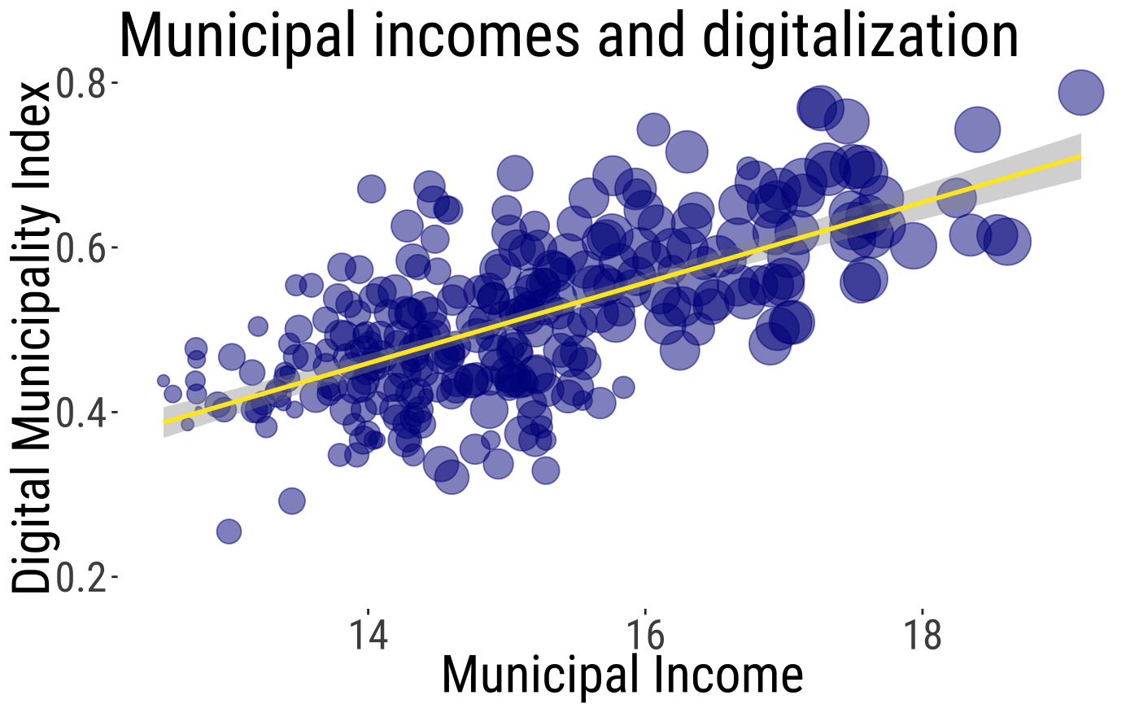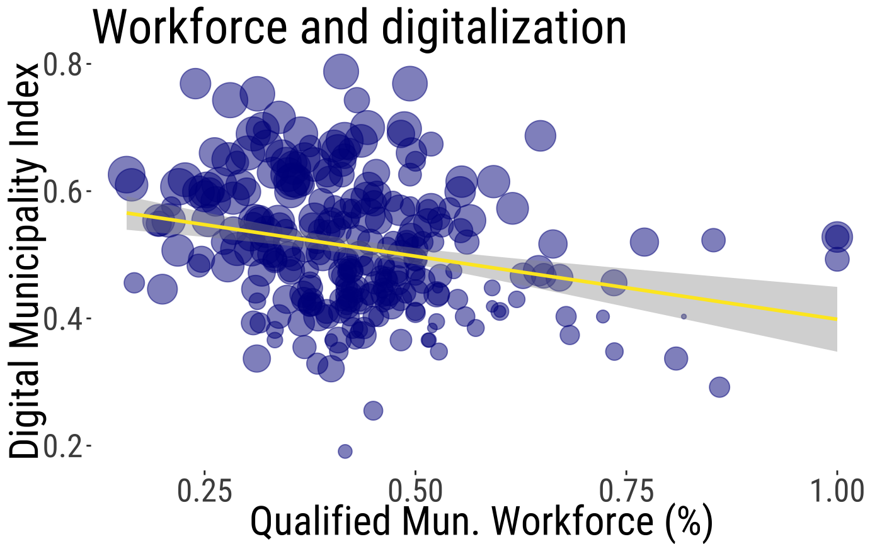

*Source: Own elaboration with data from SINIM and the Digital Municipality Index publicly available in* [*https://indice.nudos.cl/*](https://indice.nudos.cl/)

*Note: Larger circles represent municipalities with larger populations.*

An inferential approach provides a slightly different perspective. Controlling for population size and for territorial fixed effects—by regions—, municipal income is a strong predictor of a higher digitisation index, but rurality and the formal qualifications of the municipal workforce are not significant coefficients. Thus, as hypothesised (H1) the results suggest that the wealthiest municipalities tend to offer more digital services to their residents (see Table 2), but rurality (H2) and workforce qualifications (H3) do not.

**Table 2.** OLS for DMI at the municipal level

|  |  |  |
| --- | --- | --- |
|  | **Coef.** | **Coef.** |
| Rural Population (%) | 0.001 | 0.002 |
|  | (0.026) | (0.028) |
| Municipal Income (log) | 0.033*** | 0.035*** |
|  | (0.007) | (0.007) |
| Qualified Municipal Workforce (%) | -0.033 | -0.017 |
|  | (0.036) | (0.037) |
| Population size (log) | 0.02* | 0.019* |
|  | (0.008) | (0.009) |
| Region Fixed Effect | NO | YES |

*Note: Std. err. In (). p-value < .1 †; p-value < 0.05 *; p-value < 0.005 **; p-value < 0.001 ***.*

Due to longstanding issues with centralisation, territorial concentration, and cultural diversity in Chile, it is likely that regional contexts influence the observed patterns. For this reason, the analysis also examined whether the results remain consistent across the country’s macro-zones. The findings indicate that in southern and central Chile, municipal income influences levels of digitisation, whereas in northern Chile municipal income is no longer significant (see Figure 4).

**Figure 4.** OLS for DMI at the municipal level (central, southern and northern Chile)

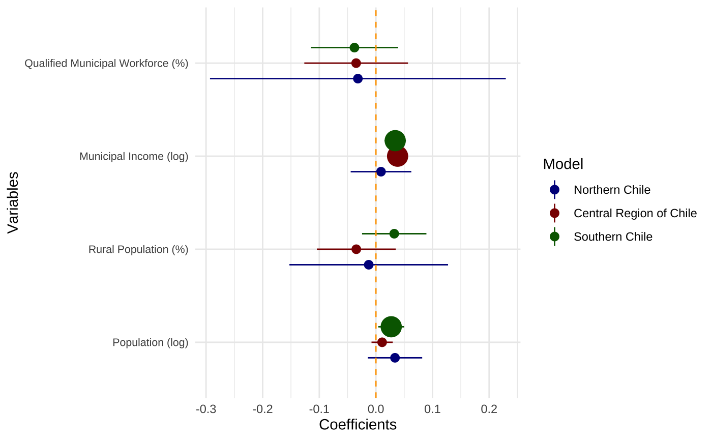

*Note: In the figure are presented the coefficients with the confidence interval at the 90%. The large circle indicates a significance with a p-value < 0.1. Small circles indicate a p-value > 0.1.*

### Local Analysis at the Individual Level

Regressions were conducted, to test hypotheses about whether individual and contextual variables (i.e. municipal digitisation and wealth) are associated with digital political engagement in relation to both attitudinal (i.e. Online Political Efficacy (OPE)- H4a/b) and behavioural (i.e. effective use of municipal websites - H5a/b) components.

The attitudinal component of engagement presents a complex picture (see Table 3). Living in a digitised municipality (H5a) does not appear to impact OPE (i.e. individuals' beliefs that the internet empowers citizens politically). However, the other contextual factor, living in a wealthy municipality (H5b), shows a negative, marginally significant relationship with this attitude. In other words, when controlling for the level of digitisation of each local government, general interest in politics, and socio-demographic characteristics of the individual, individuals residing in marginalised areas with poorer municipalities are more likely to view the Internet as a valuable tool for amplifying their political voice.

These findings are not universal for all individual aspects of OPE. Respondents living in poorer municipalities are more likely to believe that the Internet helps them understand politics better (“understanding”). Interestingly, when considering individual socioeconomic status, the pattern is reversed: individuals with higher socioeconomic status are more likely to report greater OPE, a result that is robust and consistent across models. Unsurprisingly, individual general political interest is very strongly related to OPE.

**Table 3.** OLS for Attitudinal engagement (Online Political Efficacy) at the Individual Level

|  |  |  |  |  |  |
| --- | --- | --- | --- | --- | --- |
|  | **OPE** | **power** | **voice** | **understanding** | **concern** |
| ***Contextual dimension*** |  |  |  |  |  |
| Living in a digitalised municipality | 0.18 | 0.364 | 0.193 | 0.243 | -0.013 |
|  | (0.297) | (0.435) | (0.396) | (0.194) | (0.474) |
| Living in a Wealthy Municipality | -0.028† | -0.023 | -0.032 | -0.047* | -0.04 |
|  | (0.016) | (0.026) | (0.023) | (0.023) | (0.028) |
| ***Attitudes*** |  |  |  |  |  |
| Political Interest | 0.401*** | 0.435*** | 0.514*** | 0.538*** | 0.373*** |
|  | (0.028) | (0.031) | (0.039) | (0.039) | (0.044) |
| ***Sociodemographic*** |  |  |  |  |  |
| Gender (Woman) | -0.123*** | -0.147*** | -0.157*** | -0.163*** | -0.097*** |
|  | (0.019) | (0.025) | (0.032) | (0.011) | (0.02) |
| Age | -0.006*** | -0.005*** | -0.007*** | -0.015*** | -0.000 |
|  | (0.000) | (0.001) | (0.001) | (0.001) | (0.001) |
| SES | 0.061*** | 0.077*** | 0.066*** | 0.099*** | 0.056*** |
|  | (0.014) | (0.018) | (0.02) | (0.013) | (0.016) |
| ***Year Fixed Effect*** | YES | YES | YES | YES | YES |

*Note: Std. Err. In (). p-value < .1 †; p-value < 0.05 *; p-value < 0.005 **; p-value < 0.001 ***. All models were estimated with clustered standard errors, specifically to account for the inclusion of contextual variables.*

The results are more consistent for the behavioural dimension of digital local engagement (see Table 4). However, the relationship between living in a wealthy municipality and digital engagement (H5b) is statistically significant—and again, negative. In other words, while residents of more digitalised municipalities may be somewhat more likely to engage with municipal websites, those living in wealthier municipalities are consistently less likely to do so, even when controlling for the level of local digitisation. This negative association holds across all indicators of awareness and effective use of these platforms. Nevertheless, living in a digitised municipality (H5a) is positively and significantly related to only one specific use of municipal websites (“other uses”), this association does not extend to the other individual indicators or to the overall index. As for other variables in the model, individual socioeconomic status mirrors the pattern observed for attitudinal engagement: individuals with higher socioeconomic status are more likely to use digital platforms. These findings reinforce the earlier conclusion that digital tools may play a particularly important role in promoting political inclusion at the spatial level—supporting residents of marginalised areas—rather than simply reflecting individual-level advantages.

**Table 4.** Logistic regressions for behavioural engagement (Municipality Webpage use) at the Individual Level

|  |  |  |  |  |  |  |
| --- | --- | --- | --- | --- | --- | --- |
|  | know_web | use(factor) | use_adm | use_info | use_transp | use_other |
| ***Contextual dimension*** |  |  |  |  |  |  |
| Living in a digitalised municipality | 1.964 | 0.215 | 2.065 | 1.8 | 0.939 | 3.235*** |
|  | (1.231) | (0.164) | (1.561) | (1.59) | (1.243) | (0.812) |
| Living in a wealthy municipality | -0.246** | -0.028* | -0.212* | -0.233* | -0.218* | -0.396*** |
|  | (0.094) | (0.012) | (0.106) | (0.114) | (0.09) | (0.093) |
| ***Attitudes*** |  |  |  |  |  |  |
| Political Interest | 0.857*** | 0.1*** | 0.761*** | 0.944*** | 1.046*** | 0.968*** |
|  | (0.072) | (0.01) | (0.083) | (0.096) | (0.082) | (0.082) |
| Online Political Efficacy | 0.102* | 0.014* | 0.051 | 0.124** | 0.143* | 0.102* |
|  | (0.047) | (0.005) | (0.066) | (0.045) | (0.062) | (0.045) |
| ***Sociodemographic*** |  |  |  |  |  |  |
| Gender (women) | 0.15* | 0.016** | -0.085† | 0.214** | 0.141** | 0.124* |
|  | (0.072) | (0.006) | (0.05) | (0.074) | (0.049) | (0.05) |
| Age | -0.024*** | -0.002*** | -0.017*** | -0.022*** | -0.022*** | -0.02*** |
|  | (0.003) | (0.000) | (0.002) | (0.003) | (0.002) | (0.004) |
| Socioeconomic Status | 0.463*** | 0.042*** | 0.405*** | 0.378*** | 0.167*** | 0.289*** |
|  | (0.049) | (0.004) | (0.044) | (0.043) | (0.046) | (0.05) |
| Year Fixed Effect | YES | YES | YES | YES | YES | YES |

*Note: Std. err. In (). p-value < .1 †; p-value < 0.05 *; p-value < 0.005 **; p-value < 0.001 ***. For use(factor), it was estimated as an OLS regression. All models were estimated with clustered standard errors, specifically to account for the inclusion of contextual variables.*

To better understand these relationships, additional models were estimated by incorporating interaction terms between spatial and individual wealth to answer RQ1 (see Tables 5 and 6). In the case of Online Political Efficacy (OPE), the interaction term is statistically marginally significant for “voice”, “concern”, and the composite factor. For municipal website use, the interaction term is only significant for the category “other uses.” Although these results are not consistent across categories, the findings suggest that while living in a poorer municipality is generally associated with higher levels of digital engagement, this effect is especially pronounced for individuals with fewer personal resources. In contrast, individuals with higher socioeconomic status tend to engage digitally regardless of where they live.

Additional results also point to broader dimensions of digital inequality. Older respondents are not only less likely to use municipal websites but also less likely to believe that the Internet enhances their political voice. Finally, while women are more likely to use municipal websites, they are less likely to perceive the Internet as politically empowering.

**Table 5.** OLS for Attitudinal Political Engagement (Online Political Efficacy), considering interactions between individual and area wealth

|  |  |  |  |  |  |
| --- | --- | --- | --- | --- | --- |
|  | **OPE Factor** | **power** | **voice** | **understanding** | **concern** |
| Wealthy Municipal X SES | 0.022† | 0.027 | 0.029* | 0.021 | 0.021† |
|  | (0.012) | (0.020) | (0.013) | (0.015) | (0.011) |
| ***Contextual dimension*** |  |  |  |  |  |
| Living in a wealthy municipality | -0.029† | -0.024 | -0.033 | -0.048* | -0.041 |
|  | (0.016) | (0.026) | (0.022) | (0.024) | (0.028) |
| Living in a digitised municipality | 0.193 | 0.380 | 0.211 | 0.255 | -0.000 |
|  | (0.292) | (0.432) | (0.389) | (0.192) | (0.470) |
| ***Sociodemographic*** |  |  |  |  |  |
| SES | 0.061*** | 0.077*** | 0.066*** | 0.098*** | 0.055*** |
|  | (0.012) | (0.308) | (0.017) | (0.012) | (0.014) |
| Age | -0.006*** | -0.005*** | -0.007*** | -0.015*** | -0.000 |
|  | (0.000) | (0.001) | (0.001) | (0.001) | (0.001) |
| Gender (Women) | -0.123*** | -0.147*** | -0.157*** | -0.163*** | -0.097*** |
|  | (0.019) | (0.024) | (0.032) | (0.011) | (0.020) |
| ***Attitudes*** |  |  |  |  |  |
| Political Interest | 0.400*** | 0.434*** | 0.513*** | 0.537*** | 0.372*** |
|  | (0.028) | (0.031) | (0.039) | (0.039) | (0.044) |
| Year Fixed Effect | YES | YES | YES | YES | YES |

*Note: Std. Err. In (). p-value < .1 †; p-value < 0.05 *; p-value < 0.005 **; p-value < 0.001 ***. All models were estimated with clustered standard errors, specifically to account for the inclusion of contextual variables. Interacted variables were centred.*

**Table 6.** Logistic regressions for Behavioural Political Engagement (Municipality Webpage use) considering interactions

|  |  |  |  |  |  |  |
| --- | --- | --- | --- | --- | --- | --- |
|  | **know_web** | **use_adm** | **use_info** | **use_transp** | **use_other** | **use(factor)** |
| Wealthy Municipal X SES | 0.004 | 0.031 | -0.014 | 0.015 | 0.045† | 0.000 |
|  | (0.060) | (0.047) | (0.055) | (0.028) | (0.027) | (0.006) |
| ***Contextual dimension*** |  |  |  |  |  |  |
| Living in a wealthy municipality | -0.247** | -0.222* | -0.229* | -0.223** | -0.417*** | -0.028* |
|  | (0.204) | (0.113) | (0.114) | (0.091) | (0.099) | (0.012) |
| Living in a digitised municipality | 1.967 | 2.085 | 1.791 | 0.949 | 3.270*** | 0.215 |
|  | (1.231) | (1.569) | (1.589) | (1.248) | (0.828) | (0.165) |
| ***Sociodemographic*** |  |  |  |  |  |  |
| SES | 0.463*** | 0.405** | 0.378*** | 0.169*** | 0.291 | 0.042*** |
|  | (0.056) | (0.046) | (0.049) | (0.044) | (0.043) | (0.005) |
| Age | -0.024*** | -0.017*** | -0.022*** | -0.022*** | -0.020*** | -0.002*** |
|  | (0.003) | (0.002) | (0.003) | (0.002) | (0.004) | (0.000) |
| Gender (Women) | 0.150* | -0.085† | 0.214** | 0.141** | 0.124* | 0.016* |
|  | (0.072) | (0.050) | (0.075) | (0.049) | (0.050) | (0.006) |
| ***Attitudes*** |  |  |  |  |  |  |
| Political Interest | 0.856*** | 0.760*** | 0.945*** | 1.045*** | 0.966*** | 0.100*** |
|  | (0.073) | (0.083) | (0.096) | (0.082) | (0.083) | (0.010) |
| Online Political Efficacy | 0.102* | 0.050 | 0.124** | 0.142* | 0.100* | 0.014* |
|  | (0.048) | (0.067) | (0.046) | (0.062) | (0.044) | (0.006) |
| ***Year Fixed Effect*** | YES | YES | YES | YES | YES | YES |

*Note: Std. err. In (). p-value < .1 †; p-value < 0.05 *; p-value < 0.005 **; p-value < 0.001 ***. For use(factor), it was estimated as an OLS regression. All models were estimated with clustered standard errors. Interacted variables were centred.*

**Figure 5.** Interaction effects for Attitudinal Political Engagement (Online Political Efficacy)

*Source: Own elaboration based on results shown in Table 5.*

**Figure 6.** Interaction effects for Behavioural Political Engagement (Use of Municipal Website)

*Source: Own elaboration based on results shown in Table 6.*

## CONCLUSION AND POLICY IMPLICATIONS

* 1. **Conclusion and further research**

A growing body of scholarship has highlighted the existence of “left-behind” areas—territories where citizens are more likely to experience political disengagement and negative perceptions of politics and its processes (De Ruyter et al., 2021; Dijkstra et al., 2020). Chile is no exception. Longstanding patterns of centralisation and spatial concentration have shaped the Chilean state, creating marked disparities in the political and administrative experiences of citizens depending on their geographic location (OECD, 2009, 2017). These challenges go beyond the divide between Santiago and the rest of the country; they also manifest in intra-regional inequalities and historical neglect, contributing to deeper feelings of political segregation (Fierro, et al., 2025). Digital inequalities between citizens and the uneven digitisation of local governments compound the already significant challenges for spatial inclusion when it comes to increasing engagement with government services.

In this context, the study set out to explore whether the digital transformation of local governments—particularly through digitisation—could foster greater engagement with local government among residents of marginalised areas. However, while the Internet has often been framed as a tool capable of overcoming territorial barriers and integrating excluded populations into political life, recent scholarship has lent weight to the stratification hypothesis, which suggests that offline inequalities are often replicated in the digital sphere (van Deursen et al., 2017). This study offers further support for this view but also provides evidence for the potential benefits of local digitisation, especially for the most economically excluded living in the most deprived areas.

Although residents of less wealthy municipalities—those typically excluded from traditional political discourse in centralised countries—appear to value the Internet and digital platforms as tools for political engagement, the availability and quality of digital services remain heavily shaped by pre-existing territorial inequalities. Wealthier municipalities are the ones most likely to offer digital services, reinforcing rather than reducing gaps in local political engagement. This helps to explain the study’s more nuanced findings at the local level. The most important contribution this paper makes is to show that, while digitisation does not make much of a difference for wealthy citizens or for those living in wealthy areas, digitalisation of municipalities can serve as a gateway to digital engagement with government services and political empowerment, especially for poorer individuals in poorer areas who have little access to other routes to participation. This means that targeted investment in digitisation in under-resourced areas has the potential to mitigate inequalities in political participation. However, due to spatial inequalities these are still the areas less likely to receive funding and other resources for digitisation.

An important area for future research is how spatial inequalities shape the use of national digital public services, such as e-government platforms, or how they shape broader patterns of online civic participation. Preliminary evidence indicates that individuals who are less likely to engage with government institutions offline, due to historical or more structural marginalisation, are also less likely to have quality digital access and skills (Helsper, 2021). Yet, if they overcome these barriers, for example through provision of subsidised access, devices or digital literacy training, these same individuals may become more engaged in digital civic activities than their more privileged counterparts (Dodel & Acosta, 2024). One possible explanation is that marginalised populations often have a greater need for government services, and once they gain access to digital tools, they use them intensively. Especially because there is also evidence that the outcomes they experience, such as satisfaction with e-government services or the ease of completing digital interactions, tend to be of lower quality, contributing to growing frustration and less satisfaction with digital governance (e.g. Ali, 2021; Schou & and Hjelholt, 2019). Future research should thus look at how the processes uncovered in this paper play out over time, continuing to look at how the local digital, social and political context shapes the opportunities of especially the less privileged.

* 1. **Policy implications**

This study highlights the need to approach digital inequalities through a spatial lens. In Chile and across much of Latin America, the legacy of centralised governance has led to a persistent neglect of spatial dimensions in policy design. Most existing policies tend to focus primarily on individual-level characteristics to address interpersonal inequalities. While such an approach is necessary, it is insufficient on its own. Addressing spatial inequalities demands a more territorial perspective that accounts for structural disparities between regions and municipalities.

In the specific case of digitalisation, spatial inequality should not be reduced to the rural–urban divide. In highly centralised and territorially concentrated countries, spatial disparities are also shaped by cultural, economic, and political factors. These dimensions must be acknowledged in the formulation of public programmes aimed at fostering digital inclusion.

Additionally, given the layered and interdependent nature of local digital and spatial inequalities, it would be unwise to delegate the responsibility for digital transformation solely to local governments. Municipalities across the country face wide disparities in fiscal and administrative capacity. A more active role from the central government is required—through the implementation of coordinated national strategies and the allocation of targeted resources—to ensure that digitisation effectively contributes to narrowing territorial gaps and promoting more equitable forms of digital citizenship. Importantly, this should not take the form of isolated injections of “digital capital,” but rather sustained investment accompanied by high-quality services tailored to the needs of the most underserved populations.

Finally, efforts to enhance citizen empowerment through digital means must be coupled with initiatives to strengthen state responsiveness and institutional accountability. Without tangible improvements in the quality of public services or local governance, increased use of digital platforms could lead to growing frustration, disillusionment, or even political disengagement. If digital participation fails to produce meaningful outcomes, there is a risk that existing inequalities may be exacerbated, further fuelling political alienation and territorial polarisation.

## REFERENCES

Ali, C. (2021). *Farm Fresh Broadband: The Politics of Rural Connectivity*. The MIT Press.

Bargsted, M. A., & Somma, N. M. (2013). Social cleavages and political dealignment in contemporary Chile, 1995–2009. *Party Politics*, *22*(1), 105–124. https://doi.org/10.1177/1354068813514865

Beynon-Davies, P. (2005). Constructing electronic government: The case of the UK inland revenue. *International Journal of Information Management*, *25*(1), 3–20. https://doi.org/10.1016/j.ijinfomgt.2004.08.002

Botrić, V., & and Božić, L. (2021). The digital divide and E-government in European economies. *Economic Research-Ekonomska Istraživanja*, *34*(1), 2935–2955. https://doi.org/10.1080/1331677X.2020.1863828

Cairncross, F. (1997). *The Death of Distance: How the Communications Revolution is Changing Our Lives*. Harvard Business School Press.

Campbell, A., Gurin, G., & Miller, W. E. (1954). *The voter decides*. Row, Peterson & Co.

Cordelia, A. (2007). E-government: Towards the E-Bureaucratic Form? *Journal of Information Technology*, *22*(3), 265–274. https://doi.org/10.1057/palgrave.jit.2000105

Correa, T., Pavez, I., & Contreras, J. (2017). Beyond access: A relational and resource-based model of household Internet adoption in isolated communities. *Telecommunications Policy*. https://doi.org/10.1016/j.telpol.2017.03.008

Correa, T., Pavez, I., & Contreras, J. (2021). Digital inequality and mobiles: Opportunities and challenges of relying on smartphones for digital inclusion in disadvantaged contexts. In E. Hargittai (Ed.), *Handbook of Digital Inequality*. Elgar. https://doi.org/10.4337/9781788116572

Cramer, K. J. (2012). Putting Inequality in Its Place: Rural Consciousness and the Power of Perspective. *American Political Science Review*, *106*(3), 517–532. Cambridge Core. https://doi.org/10.1017/S0003055412000305

Datta, A. (2023). The digitalising state: Governing digitalisation-as-urbanisation in the global south. *Progress in Human Geography*, *47*(1), 141–159. https://doi.org/10.1177/03091325221141798

De Ruyter, A., Martin, R., & Tyler, P. (2021). Geographies of discontent: Sources, manifestations and consequences. *Cambridge Journal of Regions, Economy and Society*, *14*(3), 381–393. https://doi.org/10.1093/cjres/rsab025

Di Maggio, P., Hargittai, E., Celeste, C., & Shafer, S. (2004). Digital Inequality. In K. M. Neckerman (Ed.), *Social Inequality*. The Russell Sage Foundation.

Dijkstra, L., Poelman, H., & Rodríguez-Pose, A. (2020). The geography of EU discontent. *Regional Studies*, *54*(6), 737–753. https://doi.org/10.1080/00343404.2019.1654603

Dodel, M. (2024). Why Device-Related Digital Inequalities Matter for E-Government Engagement? *Social Science Computer Review*, *42*(1), 122–142. https://doi.org/10.1177/08944393231176595

Dodel, M., & Acosta, M. J. (2024). When Lockdowns Force “Everyone” to Work From Home: Inequalities in Telework During COVID-19 in Uruguay. *American Behavioral Scientist*, *68*(8), 1007–1031. https://doi.org/10.1177/00027642231155370

Essletzbichler, J., & Forcher, J. (2022). “Red Vienna” and the rise of the populist right. *European Urban and Regional Studies*, *29*(1), 126–141. https://doi.org/10.1177/09697764211031622

Faggian, A., Modica, M., Modrego, F., & Urso, G. (2021). One country, two populist parties: Voting patterns of the 2018 Italian elections and their determinants. *Regional Science Policy & Practice*, *13*(2), 397–413. https://doi.org/10.1111/rsp3.12391

Fierro, P., Aroca, P., & Navia, P. (2023). The center-periphery cleavage and online political efficacy (OPE): Territorial and democratic divide in Chile, 2018–2020. *New Media & Society*, *25*(6), 1335–1353. https://doi.org/10.1177/14614448211019303

Fierro, P., Aroca, P., & Navia, P. (2025). *Abandoned Places in the Digital Era. Spatial Roots of Disaffection and the Internet’s Role in Inclusion* (First). Springer Nature.

Fierro, P., Rivera, S., & Brieba, D. (2025). The effects of marginalisation in areas of high political centralisation. *Territory, Politics, Governance*, 1–24. https://doi.org/10.1080/21622671.2024.2435888

Gasco Hernandez, M. (2024). Reflections on three decades of digital transformation in local governments. *Local Government Studies*, 1–13. https://doi.org/10.1080/03003930.2024.2410830

Gerpott, T. J., & Ahmadi, N. (2016). Use levels of electronic government services among German citizens. *Transforming Government: People, Process and Policy*, *10*(4), 637–668. https://doi.org/10.1108/TG-05-2016-0025

Gil-Garcia, J. R., Dawes ,Sharon S., & and Pardo, T. A. (2018). Digital government and public management research: Finding the crossroads. *Public Management Review*, *20*(5), 633–646. https://doi.org/10.1080/14719037.2017.1327181

Gillespie, A., & Robins, K. (1989). Geographical Inequalities: The Spatial Bias of the New Communications Technologies. *Journal of Communication*, *39*(3), 7–18. https://doi.org/10.1111/j.1460-2466.1989.tb01037.x

Graham, M., De Sabbata, S., Straumann, R. K., & Ojanperä, S. (2018). Uneven Digital Geographies... And Why They Matter. In K. Orangotango+ (Ed.), *This is Not an Atlas* (transcript).

Graham, M., Hale, S., & Stephens, M. (2012). Featured Graphic: Digital Divide: The Geography of Internet Access. *Environment and Planning A: Economy and Space*, *44*(5), 1009–1010. https://doi.org/10.1068/a44497

Hargittai, E. (2010). Digital Na(t)ives? Variation in Internet Skills and Uses among Members of the “Net Generation”. *Sociological Inquiry*, *80*(1), 92–113. https://doi.org/10.1111/j.1475-682X.2009.00317.x

Haro-de-Rosario, A., Sáez-Martín, A., & del Carmen Caba-Pérez, M. (2016). Using social media to enhance citizen engagement with local government: Twitter or Facebook? *New Media & Society*, *20*(1), 29–49. https://doi.org/10.1177/1461444816645652

Hechler, S., Chayinska, M., Wekenborg, C. S., Moraga-Villablanca, F., Kessler, T., & McGarty, C. (2024). Why Chile “Woke Up.” Antecedents of the Formation of Prochange Group Consciousness Promoting Collective Action. *Political Psychology*, *45*(1), 3–21. https://doi.org/10.1111/pops.12906

Helsper, E. J. (2021). *The Digital Disconnect: The Social Causes and Consequences of Digital Inequalities*. Sage.

INDH. (2019). *Informe Anual 2019: Situación de los Derechos Humanos en Chile en el Contexto de la Crisis Social*. Instituto Nacional de Derechos Humanos (INDH). https://bibliotecadigital.indh.cl/server/api/core/bitstreams/9b8845b0-9bfe-46fd-8063-26184ca1a3e7/content

Janssen, M., & van der Voort, H. (2016). Adaptive governance: Towards a stable, accountable and responsive government. *Government Information Quarterly*, *33*(1), 1–5. https://doi.org/10.1016/j.giq.2016.02.003

Kneuer, M., & Datts, M. (2020). E-democracy and the Matter of Scale. Revisiting the Democratic Promises of the Internet in Terms of the Spatial Dimension. *Politische Vierteljahresschrift*, *61*(2), 285–308. https://doi.org/10.1007/s11615-020-00250-6

Lappas, G., Triantafillidou, A., & Kani, A. (2022). Harnessing the power of dialogue: Examining the impact of facebook content on citizens’ engagement. *Local Government Studies*, *48*(1), 87–106. https://doi.org/10.1080/03003930.2020.1870958

Larsson, K. K. (2021). Digitization or equality: When government automation covers some, but not all citizens. *Government Information Quarterly*, *38*(1), 101547. https://doi.org/10.1016/j.giq.2020.101547

Luna, J. P. (2016). Chile’s Crisis of Representation. *Journal of Democracy*, *27*(3), 129–138. https://doi.org/10.1353/jod.2016.0046

Madsen, C. Ø., Lindgren, I., & Melin, U. (2022). The accidental caseworker – How digital self-service influences citizens’ administrative burden. *Government Information Quarterly*, *39*(1), 101653. https://doi.org/10.1016/j.giq.2021.101653

Mainwaring, S., & Scully, T. R. (2008). Latin America: Eight lessons for governance. *Journal of Democracy*, *19*, 113–127. https://doi.org/10.1353/jod.0.0001

McCann, P. (2020). Perceptions of regional inequality and the geography of discontent: Insights from the UK. *Regional Studies*, *54*(2), 256–267. https://doi.org/10.1080/00343404.2019.1619928

Mergel, I., Edelmann, N., & Haug, N. (2019). Defining digital transformation: Results from expert interviews. *Government Information Quarterly*, *36*(4), 101385. https://doi.org/10.1016/j.giq.2019.06.002

Mossberger, K., Tolbert, C. J., Bowen, D., & Jimenez, B. (2012). Unraveling Different Barriers to Internet Use: Urban Residents and Neighborhood Effects. *Urban Affairs Review*, *48*(6), 771–810. https://doi.org/10.1177/1078087412453713

Mossberger, K., Tolbert, C. J., & LaCombe, S. J. (2021). *Choosing the Future: Technology and Opportunity in Communities*. Oxford University Press. https://doi.org/10.1093/oso/9780197585757.001.0001

Navarrete, B., & Tricot, V. (2021). Introduction: Social Outbreak and Political Representation in Latin America. In B. Navarrete & V. Tricot (Eds.), *The Social Outburst and Political Representation in Chile* (pp. 1–10). Springer International Publishing. https://doi.org/10.1007/978-3-030-70320-2_1

OECD. (2009). *OECD Territorial Reviews. Chile*. OECD.

OECD. (2017). *Making Decentralisation Work in Chile*. https://www.oecd-ilibrary.org/content/publication/9789264279049-en

Paredes, F., Coddou Mc Manus, A., & Suiter, J. (2025). Constitutional Change and Referendums in Chile and Ireland: Faraway, So Close. *Politics and Governance; Vol 13 (2025): Cleavage Referendums: Ideological Decisions and Transformational Political Change*. https://doi.org/10.17645/pag.9197

Pavez, I., Correa, T., & Farías, C. (2023). The Power of Emotions: The Ethics of Care in the Digital Inclusion Processes of Marginalized Communities. *Social Inclusion; Vol 11, No 3 (2023): Expanding the Boundaries of Digital Inclusion: Perspectives From Network Peripheries and Non-Adopters*. https://doi.org/10.17645/si.v11i3.6623

Pavez, I., Correa, T., Farías, C., & Tobar, N. (2025). Are we there yet? The persistent digital marginalization of remote rural communities: A mixed-method longitudinal study (2014-2023). *Paper Presented at the International Communication Association Annual Conference. Denver, US.*

Pérez, M. (2016). Análisis de los municipios chilenos: Ingresos por gestión versus transferencias del Fondo Común Municipal. *Revista Estudios de Políticas Públicas*, *2*(2), 121–130. https://doi.org/10.5354/0719-6296.2016.44264

Ragnedda, M., & Ruiu, M. L. (2019). Social capital and the three levels of digital divide. In M. Ragnedda & G. Muschert (Eds.), *Theorizing Digital Divides* (1st ed., pp. 21–34). Rutledge.

Roberts, K. M. (2015). *Changing Course in Latin America: Party Systems in the Neoliberal Era*. Cambridge University Press; Cambridge Core. https://doi.org/10.1017/CBO9780511842856

Robinson, L., Cotten, S. R., Ono, H., Quan-Haase, A., Mesch, G., Chen, W., Schulz, J., Hale, T. M., & Stern, M. J. (2015). Digital inequalities and why they matter. *Information, Communication & Society*, *18*(5), 569–582. https://doi.org/10.1080/1369118X.2015.1012532

Robles, J. M., Torres-Albero ,Cristobal, & and Villarino, G. (2022). Inequalities in digital welfare take-up: Lessons from e-government in Spain. *Policy Studies*, *43*(5), 1096–1111. https://doi.org/10.1080/01442872.2021.1929916

Rodríguez-Pose, A. (2018). The revenge of the places that don’t matter (and what to do about it). *Cambridge Journal of Regions, Economy and Society*, *11*(1), 189–209. https://doi.org/10.1093/cjres/rsx024

Rodríguez-Pose, A., Dijkstra, L., & Poelman, H. (2024). The Geography of EU Discontent and the Regional Development Trap. *Economic Geography*, *100*(3), 213–245. https://doi.org/10.1080/00130095.2024.2337657

Rodríguez-Pose, A., Terrero-Dávila, J., & Lee, N. (2023). Left-behind versus unequal places: Interpersonal inequality, economic decline and the rise of populism in the USA and Europe. *Journal of Economic Geography*, *23*(5), 951–977. https://doi.org/10.1093/jeg/lbad005

Saha, P. (2009). Architecting the connected government: Practices and innovations in Singapore. In *Proceedings of the 3rd International Conference on Theory and Practice of Electronic Governance* (pp. 11–17). Association for Computing Machinery. https://doi.org/10.1145/1693042.1693046

Sasaki, F. (2016). Online Political Efficacy (OPE) as a Reliable Survey Measure of Political Empowerment When Using the Internet. *Policy & Internet*, *8*(2), 197–214. https://doi.org/10.1002/poi3.114

Sasaki, F. (2017). Does Internet use provide a deeper sense of political empowerment to the Less Educated? *Information, Communication & Society*, *20*(10), 1445–1463. https://doi.org/10.1080/1369118X.2016.1229005

Schou, J., & and Hjelholt, M. (2019). Digitalizing the welfare state: Citizenship discourses in Danish digitalization strategies from 2002 to 2015. *Critical Policy Studies*, *13*(1), 3–22. https://doi.org/10.1080/19460171.2017.1333441

Somma, N. M., Bargsted, M., Disi Pavlic, R., & Medel, R. M. (2021). No water in the oasis: The Chilean Spring of 2019–2020. *Social Movement Studies*, *20*(4), 495–502. https://doi.org/10.1080/14742837.2020.1727737

Stephens, M., & Poorthuis, A. (2015). Follow thy neighbor: Connecting the social and the spatial networks on Twitter. *Special Issue on Volunteered Geographic Information*, *53*, 87–95. https://doi.org/10.1016/j.compenvurbsys.2014.07.002

Subtel. (2023). *Décima Encuesta sobre acceso, usos y usuarios de Internet en Chile*. Subsecretaría de Telecomunicaciones.

Takhteyev, Y., Gruzd, A., & Wellman, B. (2012). Geography of Twitter networks. *Capturing Context: Integrating Spatial and Social Network Analyses*, *34*(1), 73–81. https://doi.org/10.1016/j.socnet.2011.05.006

Torcal, M., & Montero, J. R. (2006). *Political Disaffection in Contemporary Democracies*. Routledge.

Toro-Maureira, S., Olivares, A., Sáez-Vergara, R., Valenzuela, S., Valenzuela, M., & Correa, T. (2025). The Missing Link: Identifying Digital Intermediaries in E-Government. *Public Administration Review*, *n/a*(n/a). https://doi.org/10.1111/puar.70033

van Deursen, A., Helsper, E., Eynon, R., & Dijk, J. van. (2017). The Compoundness and Sequentiality of Digital Inequality. *International Journal of Communication; Vol 11 (2017)*. https://ijoc.org/index.php/ijoc/article/view/5739

van Deursen, A., & Helsper, E. J. (2015). The Third-Level Digital Divide: Who Benefits Most from Being Online? In *Communication and Information Technologies Annual* (Vol. 10, pp. 29–52). Emerald Group Publishing Limited. https://doi.org/10.1108/S2050-206020150000010002

van Deursen, A., & van Dijk, J. (2014). The digital divide shifts to differences in usage. *New Media & Society*, *16*(3), 507–526. https://doi.org/10.1177/1461444813487959

van Dijk, J. (2020). *The Digital Divide* (1st ed.). Polity.

Whitacre, B., Strover, S., & Gallardo, R. (2015). How much does broadband infrastructure matter? Decomposing the metro–non-metro adoption gap with the help of the National Broadband Map. *Government Information Quarterly*, *32*(3), 261–269. https://doi.org/10.1016/j.giq.2015.03.002

Ziblatt, D., Hilbig, H., & Bischof, D. (2023). Wealth of Tongues: Why Peripheral Regions Vote for the Radical Right in Germany. *American Political Science Review*, 1–17. Cambridge Core. https://doi.org/10.1017/S0003055423000862

1. Internally generated ‘Ingresos propios permanentes’ are the main source of financing for local municipalities in Chile, surpassing external funds and programmes provided by the central government (Pérez, 2016).